Additional data

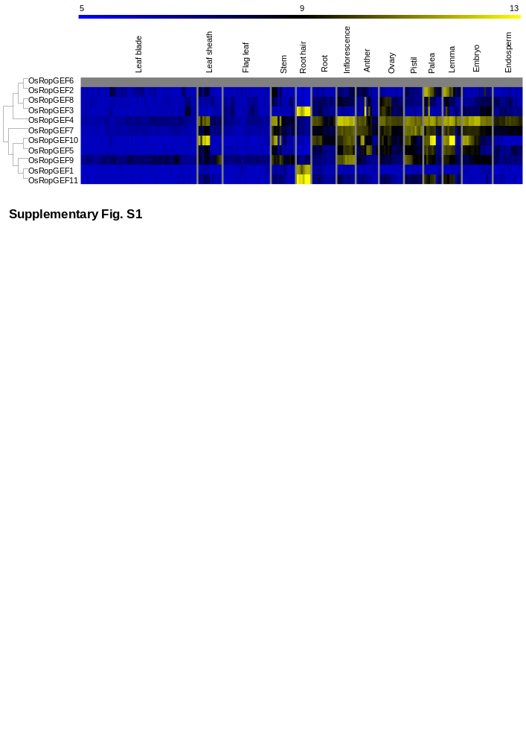
Additional file 1: Figure S1. Meta-expression analysis and genome-wide identification of every OsRopGEF. OsRopGEF expression was observed in all tissues except pollen. Yellow color in the heatmap indicates high level of expression; dark blue, low level of expression. Numeric values indicate the average of the normalized log2 intensity of microarray data.

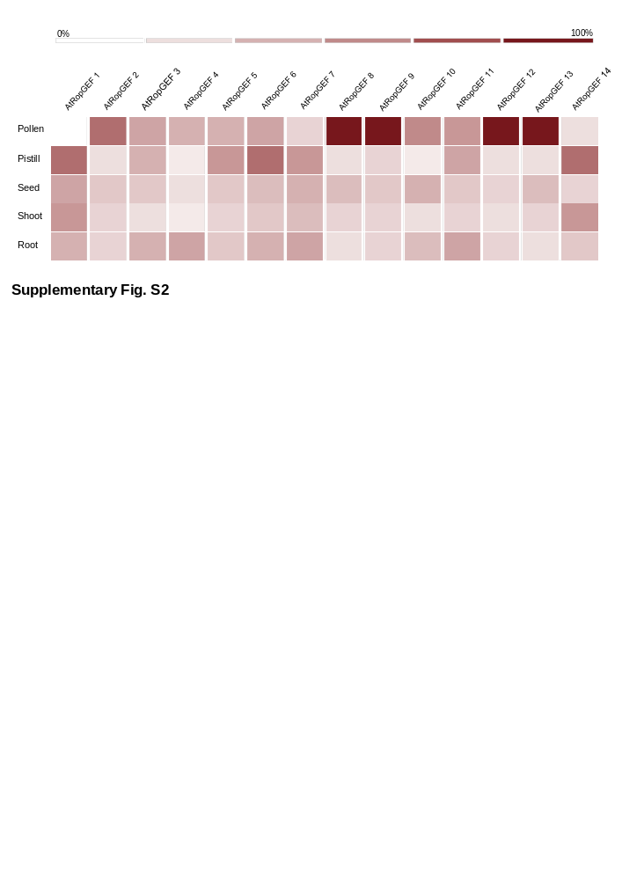
Additional file 2: Figure S2. Meta-expression analysis of entire AtRopGEF genes. The heatmap was prepared using the Genevestigator. We chose five representative tissues, including pollen. It revealed that five Arabidopsis RopGEFs were highly expressed in pollen. The dark red color of the heatmap indicated the highest expression; white color, lowest expression.
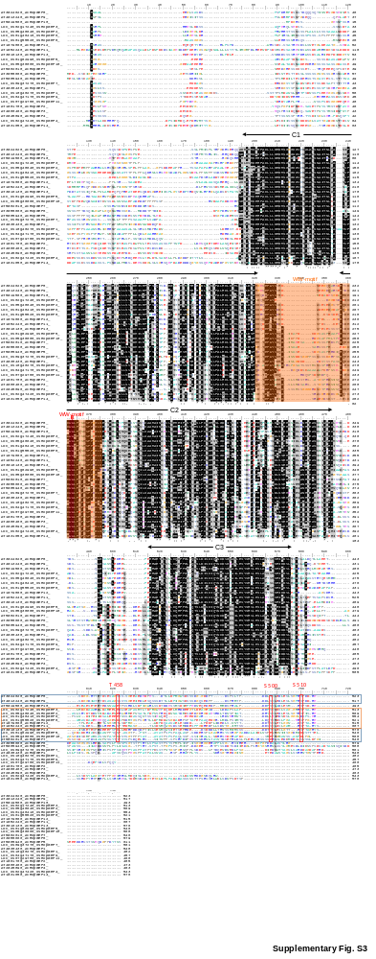
Additional file 3: Figure S3. Protein sequence alignment domain analysis and conserved phosphorylated amino acid residues of C-termini of RopGEF genes. Every OsRopGEF and AtRopGEF protein sequence was collected and aligned, followed by the PRONE domain (C1, C2, C3) and the WW-motif. At the end part of the sequence, we found some conserved regions. According to previous studies, S510 in the C-terminus of AtRopGEF12 is involved in the C-terminal inhibition of GEF activity. As in AtRopGEF12, the serine residue is conserved in each of the OsRopGEF2, OsRopGEF3, and OsRopGEF8 genes but not in OsRopGEF6. However, K (Lysine) can also be phosphorylated.

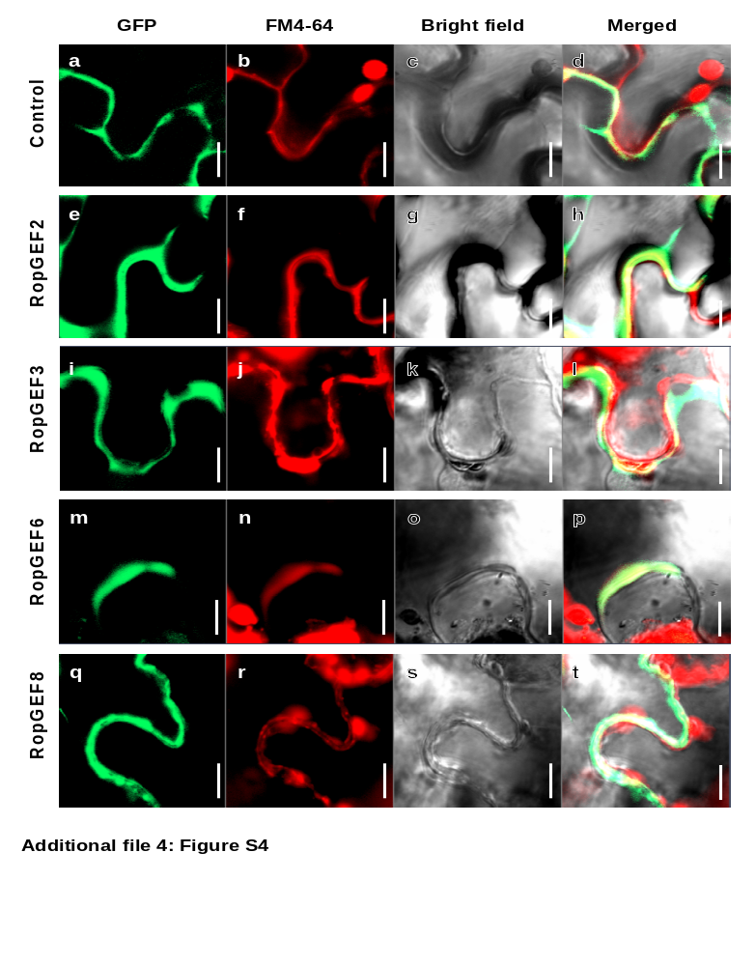Additional file 4: Figure S4. Zoom-image of the tobacco localization confocal pictures. It shows an enlarged portion of figure 5. The focused zoom-image to the plasma membrane (PM). First, RopGEF-GFP signal shows on the left. Next, the membrane marker FM4-64 staining picture shows the plasma membrane. The final photo is a merged picture of GFP and RFP channel, and the RopGEF-GFP signal is detected in the membrane. In addition to the membrane signal, the large spot seen in the RFP channel is due to Chlorophyll's auto fluorescence. a-d, Control (pGREEN-GFP); e-h, RopGEF 2; i-l, RopGEF3; m-p, RopGEF6; q-t, RopGEF8. Bars = 10um.

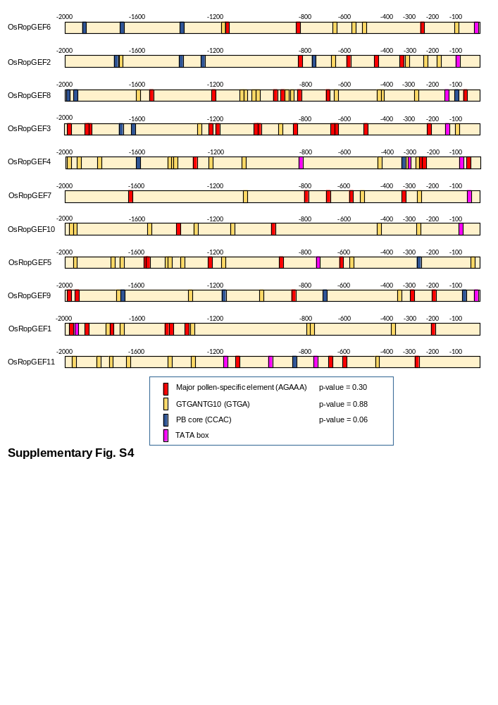
Additional file 5: Figure S5. Promoter analysis of each OsRopGEF gene. Specific-CREs known to affect expression in pollen were identified using PLACE database, namely three pollen-CREs and the TATA box. The number above the yellow bar shows the upstream position of the promoter base pair when taken at +1 of ATG. We analyzed up to the upstream 2,000-base pair. The p-values indicate how significantly the four genes exhibiting high expression in pollen differed from the other seven genes.

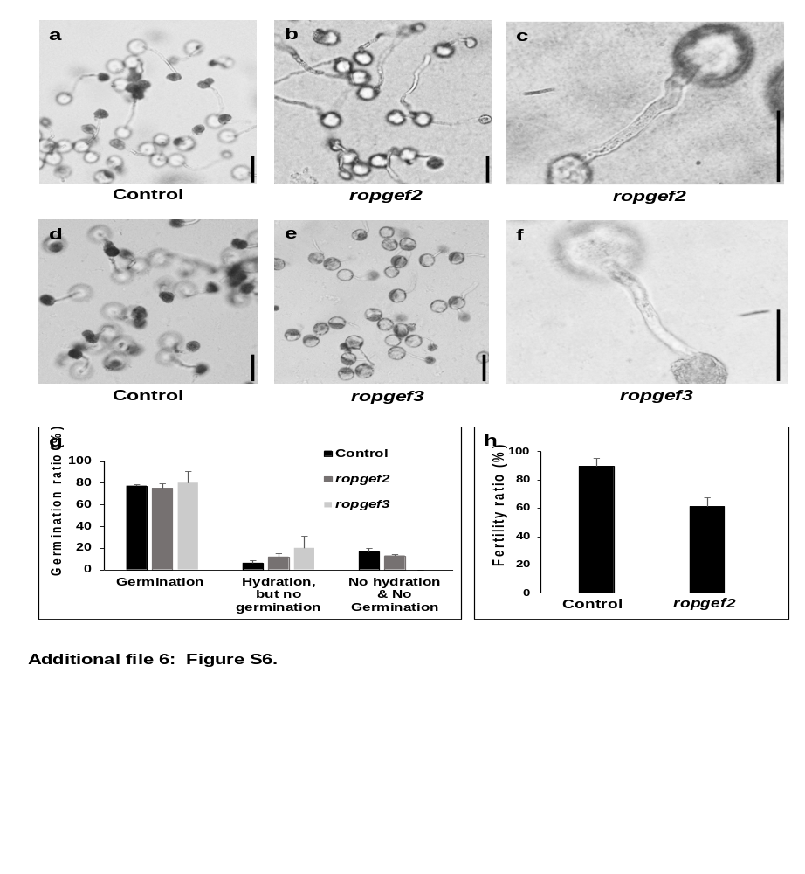Additional file 6: Figure S6. Single mutant assay using CRISPR-Cas9 system. (a-b, d-e) In-vitro pollen germination test of wild-type (a, d), ropgef2 (b, c), and ropgef3 (e-f) single mutants in solid pollen media, Bar = 50 µm; (c,f) enlarged pollen pictures, Bar = 20 µm. Each control and mutant pollen in-vitro assays were performed in the same environment on the same day. (g) The ratio of pollen germination. Black bar indicates wild type; grey bar indicates ropgef2; white bar indicates ropgef3 mutant pollen. Error bars are standard deviation of three technical repeats. (h) Fertility ratio comparison between wild-type and ropgef2 single mutant plants. Error bars are standard deviation of more than three panicles in the plants.

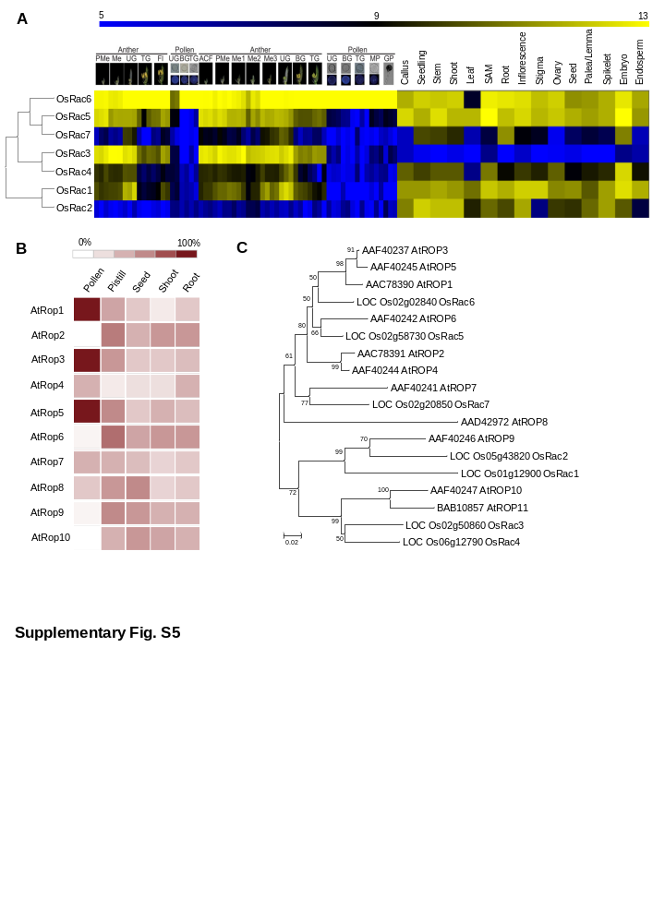
Additional file 7: Figure S7. Meta-expression analysis and genome-wide identification of the seven OsRac and ten AtRop genes. (A) Heatmap expression analysis of every OsRac gene. (B) Heatmap of AtRop using Genevestigator. (C) Phylogenetic tree constructs including every OsRac and AtRop.

Additional file 7: Table S1. Gene identification of RopGEF genes and RAC/ROP genes.
Gene | Locus | NCBI Gene ID | Gene | Locus | NCBI Gene ID | Gene | Locus | NCBI Gene ID
OsRopGEF1 | Loc_Os10g40270 | None | AtRopGEF1 | Loc_AT4G38430 | 830000 | AtROP1 | Loc_AT3G51300 | 824293
OsRopGEF2 | Loc_Os05g48640 | None | AtRopGEF2 | Loc_AT1G01700 | 839250 | AtROP2 | Loc_AT1G20090 | 838598
OsRopGEF3 | Loc_Os02g17240 | None | AtRopGEF3 | Loc_AT4G00460 | 827967 | AtROP3 | Loc_AT2G17800 | 816290
OsRopGEF4 | Loc_Os02g47420 | None | AtRopGEF4 | Loc_AT2G45890 | 819197 | AtROP4 | Loc_AT5G45970 | 834637
OsRopGEF5 | Loc_Os01g62990 | None | AtRopGEF5 | Loc_AT5G05940 | 831858 | AtROP5 | Loc_AT4G35950 | 829750
OsRopGEF6 | Loc_Os01g48410 | None | AtRopGEF6 | Loc_AT3G55660 | 824732 | AtROP6 | Loc_AT4G35020 | 829654
OsRopGEF7 | Loc_Os09g37270 | None | AtRopGEF7 | Loc_AT5G02010 | 830000 | AtROP7 | Loc_AT5G45970 | 834637
OsRopGEF8 | Loc_Os01g55520 | None | AtRopGEF8 | Loc_AT3G24620 | 822058 | AtROP8 | Loc_AT2G44690 | 819077
OsRopGEF9 | Loc_Os04g47170 | None | AtRopGEF9 | Loc_AT4G13240 | 826941 | AtROP9 | Loc_AT4G28950 | 829016
OsRopGEF10 | Loc_Os05g38000 | None | AtRopGEF10 | Loc_AT5G19560 | 832076 | AtROP10 | Loc_AT3G48040 | 823959
OsRopGEF11 | Loc_Os07g29780 | None | AtRopGEF11 | Loc_AT1G52240 | 841654 | AtROP11 | Loc_AT5G62880 | 836408
OsRac1 | Loc_Os01g12900 | 4325879 | AtRopGEF12 | Loc_AT1G79860 | 844325
OsRac2 | Loc_Os02g02840 | 4328116 | AtRopGEF13 | Loc_AT3G16130 | 820858
OsRac3 | Loc_Os02g20850 | 4329132 | AtRopGEF14 | Loc_AT1G31650 | 840052
OsROP4 | Loc_Os02g50860 | 4330693
OsROP5 | Loc_Os02g58730 | 4331272
OsRacB | Loc_Os05g43820 | 4339304
OsRacD | Loc_Os06g12790 | 4340590

Additional file 9: Table S2. OsRopGEF isogene-specific primers for qPCR and pGREEN cloning, CRISPR-Cas9 cloning.

Genes | Sense Primers | Antisense Primers
qPCR
OsRopGEF2 | 5'-CATTGCTCAGTCAGCTCTTG-3' | 5'-TGAAGAACATCTTCGATTCG-3'
OsRopGEF3 | 5'-TGACGAGGAAGTGGCTGCAG-3' | 5'-AGCGACTCGATGTACACCTC-3'
OsRopGEF6 | 5'-TTCGGTATTCGGGGAGCAGC-3' | 5'-ATGCTGGTTCCATCCGTGGA-3'
OsRopGEF8 | 5'-CAAGTCTTGGACAACGGCGT-3' | 5'-TTGAAGTTGTCCAGGTAATC-3'
pGREEN cloning
OsRopGEF2 | 5'-TCGACGGTATCGATAAGCTT  ATGGCGCGGCCGCTGCTGA-3' | 5'-CAGGAATTCGATATCAAGCTT  GTGTCTAGATATTGGGCT-3'
OsRopGEF3 | 5'-TCGACGGTATCGATAAGCTT  ATGGTGCGGTTCCTCCGG-3' | 5'-CAGGAATTCGATATCAAGCTT  GTGGCGCGCGGAGGGGCT-3'
OsRopGEF6 | 5'-TCGACGGTATCGATAAGCTT  ATGGTGCGGCGGCACCTG-3' | 5'-CAGGAATTCGATATCAAGCTTC  CTATGAGAAAAGCTTTTC-3'
OsRopGEF8 | 5'-TCGACGGTATCGATAAGCTT  ATGGCAGCGAGCGGCGGT-3' | 5'-CAGGAATTCGATATCAAGCTT  ATGGCGACCTGGTGGGCTT-3'
Single CRISPR-Cas cloning
OsRopGEF3 (Target 1) | 5'-GGCAGTCGAATGCGATCACGAA CC-3' | 5'-AAACGGTTCGTGATCGCATTCG AC-3'
OsRopGEF3 (Target 2) | 5'-GGCAAGCGAGTTCTGGTACGAG AA-3' | 5'-AAACTTCTCGTACCAGAACTC GCT-3'
Multiple CRISPR-Cas cloning
OsRopGEF2 | 5'- TAGGTCTCCTCTCCGGGTCCA  GTTTTAGAGCTAGAA-3' | 5'-CGGGTCTCACATTGAGCTCAA  TGCACCAGCCGGG-3'
OsRopGEF6 | 5'-TAGGTCTCCAATGTCGCGCGC GTTTTAGAGCTAGAA-3' | 5'-CGGGTCTCATCGCCATGATCG  TGCACCAGCCGGG-3'
OsRopGEF8 | 5'-TAGGTCTCCGCGACGACTTAC  GTTTTAGAGCTAGAA-3' | 5'-CGGGTCTCAGAGATGCCGCCC  TGCACCAGCCGGG-3'

